Bahria University,
Karachi Campus


COURSE: SEL-448
SOFTWARE APPLICATIONS FOR MOBILE DEVICES
TERM: SPRING 2026, CLASS: BSE- 6 (C)

PROJECT NAME

Qataar (E-Queue System)

Group Members | Enrollment No.
Fiza Khan - Solution Architect  (Team Lead) | 02-131232-048
Alishba Maqsood - Analyst | 02-131232-118

Engr. Adnan-ur-Rehman/Engr. Saniya Sarim

Signed Remarks: Score:

1. Table of Content

1. Table of Content 2
2. System architecture and design 3
2.1 Overview 3
2.2 High-level architecture 3
2.3 Core data flow 3
2.4 Design principles applied 4
3. Implementation details (code explanation) 5
3.1 App bootstrap and Firebase initialization (lib/main.dart) 5
3.2 Notification handling (lib/services/notification_service.dart) 5
3.3 Authentication and role routing 5
3.4 Backend: REST API and scheduled jobs (server.js) 6
3.5 QR-based serving flow 7
3.6 Grocery token UI (lib/screens/grocery_token_screen.dart) 7
3.7 Route/time estimation (lib/services/route_service.dart) 8
3.8 Performance decision in HomeScreen (lib/screens/home_screen.dart) 8
4. Output screenshots 8
5. Challenges and solutions 11
Challenge 1: Reliable notification delivery and UI display 11
Challenge 2: Asynchronous Firestore document availability 11
Challenge 3: Queue timing correctness (“turn approaching” logic) 11
Challenge 4: Navigation issues after notification tap 12
Challenge 5: Performance issues with Firestore querying 12
Challenge 6: Slot capacity enforcement for grocery tokens 12

2. System architecture and design

2.1 Overview
Qataar is a token-based queue management system that supports public and private services. It enables users to:
- Browse service categories and branches
- Select a service and book a token
- Receive real-time status updates through Firebase Cloud Messaging (FCM)
- View token details including estimated waiting time
- Scan a QR code at the branch to mark a token as served
Additionally, the system supports grocery slot-based tokens, including:
- Choosing preferred time slot and priority level
- Booking a grocery token (with capacity control)
- Receiving FCM notifications for “turn approaching” and “your turn”
- Auto-skipping/advancing queue when a serving token times out

2.2 High-level architecture
The application is composed of three main parts:
- Mobile Client (Flutter)
  - Screens for login/signup, service browsing, token booking, grocery booking, dashboards, and QR scanning.
  - Firebase integration:
    - Firebase Authentication (Google Sign-In + email/password)
    - Firestore (data storage and live updates)
    - Firebase Messaging (push notifications)
  - Local notifications via flutter_local_notifications.
- Backend Server (Node.js / Express)
  - Exposes REST endpoints used by the mobile app.
  - Sends FCM notifications.
  - Performs scheduled tasks using node-cron.
  - Sends email OTP for 2FA-like verification.
- Firebase Services (Firestore + FCM + Auth)
  - Firestore stores:
    - users, categories, branches, services
    - token bookings and daily state
    - grocery stores/branches/counters/tokens and time slots
  - FCM delivers push notifications to devices.

2.3 Core data flow

A) Service token booking & notifications
- User books a service token
  - Flutter collects:
    - userId, serviceId, branchId, categoryId, fcmToken, and location/service metadata
  - The booking is saved under the backend-controlled daily token structure.
- Backend /bookings endpoint (in server.js)
  - Creates a token booking document in:
    - tokens/{date}/bookings
  - Automatically assigns next token number per service using the last token record.
  - Increments dailyTokenCounter in the service document.
- Backend sends “Booking Confirmed” FCM notification
  - Message includes a notification title/body.
- Cron job notifies “Your Turn is Near!” and “It’s Your Turn!”
  - Every minute, cron scans service definitions and checks the booking documents.
  - Rules:
    - “Approaching” when token is 2 away from currentToken.
    - “Your Turn” when booking token equals currentToken + 1.

B) Grocery token booking, queue updates & notifications
- User selects grocery preferences
  - Flutter loads live time slots (capacity and booked count).
  - User enters approximate item count.
  - User selects a preferred slot and priority.
- Backend grocery notification endpoint
  - Endpoint /grocery/notify is notification-only.
  - It validates slot capacity.
  - It ensures the backend stores/merges the user’s fcmToken into users/{userId}.
  - It sends FCM confirmation notification containing tokenNumber and computed queuePosition.
- Grocery cron job
  - Every minute:
    - Determines current serving token for each active counter.
    - If none is serving, it promotes the first waiting token.
    - Sends “Your Turn is Near!” and “It’s Your Turn!” based on tokensAhead.
- Auto-skip missed serving tokens
  - Runs every 30 seconds.
  - If a serving token has exceeded timeout (3 minutes), it:
    - Marks token as missed
    - Promotes next waiting token as serving
    - Sends FCM notifications to both affected and next user.

2.4 Design principles applied
- Event-driven UI: Flutter screens use StreamBuilder to react to Firestore snapshot updates.
- Separation of concerns:
  - UI screens in lib/screens/*
  - Networking logic in lib/services/*
  - QR-related logic in lib/services/qr_service.dart
  - Route/time estimation logic in lib/services/route_service.dart
- Performance improvement:
  - HomeScreen uses Firestore collectionGroup('branches') to avoid N+1 query patterns.
- Robust asynchronous handling:
  - UI loading states while waiting for documents.

3. Implementation details (code explanation)

3.1 App bootstrap and Firebase initialization (lib/main.dart)
Key responsibilities:
- Initialize Flutter binding and Firebase (Firebase.initializeApp()).
- Enable Firestore offline persistence using Settings(persistenceEnabled: true).
  - Helps reduce network reads and improves UX.
- Register a Firebase Messaging background handler.
- Initialize local notifications via initializeNotifications().
- MyApp requests notification permission and prints the device FCM token.

3.2 Notification handling (lib/services/notification_service.dart)
Main features:
- Creates an Android notification channel (qataar_channel).
- Handles:
  - Background messages (firebaseMessagingBackgroundHandler)
  - Foreground messages (FirebaseMessaging.onMessage.listen)
- Displays local notifications using flutterLocalNotificationsPlugin.show(...).
Important design note: routing on notification tap is limited because navigation currently logs and does not fully route without a global navigator key.

3.3 Authentication and role routing

3.3.1 Login (lib/screens/login_screen.dart)
- Supports:
  - Email/password login via Firebase Auth
  - Google Sign-In
- After authentication:
  - Fetches the user document from Firestore
  - Sends OTP using backend endpoint sendEmailOtp
  - Navigates to role-appropriate screens after OTP verification
Role-based routing includes:
- admin → Admin home page
- user → Category selection screen

3.3.2 Signup (lib/screens/signup_screen.dart)
- Creates a Firebase Auth account.
- Stores a user profile document in Firestore with:
  - name, email, and role=user.

3.3.3 Email OTP APIs (lib/services/auth_service.dart)
- sendEmailOtp(userId, email) calls:
  - POST {API_BASE_URL}/sendEmailOtp
- verifyEmailOtp(userId, otp) calls:
  - POST {API_BASE_URL}/verifyEmailOtp

3.4 Backend: REST API and scheduled jobs (server.js)
The Node.js server uses Express + Firebase Admin.

3.4.1 /bookings endpoint
- Input includes serviceId, branchId, categoryId, fcmToken, and city.
- Creates a booking document under:
  - tokens/{date}/bookings
- Assigns tokenNumber by reading the latest token for the same service.
- Increments dailyTokenCounter in the service definition document.
- Sends FCM notification: “Booking Confirmed!”.

3.4.2 /sendNotification endpoint
- Notification-only endpoint (no Firestore write).
- Used to trigger FCM sending based on token metadata.

3.4.3 /updateToken endpoint
- Updates a service definition’s currentToken.
- Used by admin or operational flow to advance the queue.

3.4.4 Grocery /grocery/notify
- Notification-only for grocery booking confirmations.
- Computes:
  - tokenNumber using today’s token count
  - queuePosition based on last in-order token with queuePosition ordering
  - priority based on numberOfItems threshold
- Validates capacity from timeSlots/{slotId}.
- Ensures user’s FCM token is stored in users/{userId}.

3.4.5 Cron jobs
- Services cron (every minute)
  - Iterates through categories → branches → services.
  - Queries bookings in tokens/{date}/bookings.
  - Sends notifications:
    - “Your Turn is Near!” at 2 tokens away.
    - “It’s Your Turn!” at currentToken + 1.
- Grocery cron (every minute)
  - Iterates through stores → branches → counters.
  - Finds serving token (status='serving') or promotes first waiting token.
  - For each waiting token:
    - Calculates tokensAhead = queuePosition - currentServingPosition.
    - Sends notifications using tokensAhead thresholds.
- Auto-skip cron (*/30 * * * * *)
  - Finds overdue serving tokens and applies transaction logic to:
    - mark as missed
    - promote next waiting token
    - notify affected next user(s)

3.5 QR-based serving flow

3.5.1 QR encoding and parsing (lib/services/qr_service.dart)
- Grocery QR data is encoded as JSON:
  - { type: 'grocery', storeId, branchId, docId, tokenNumber }

3.5.2 Mark token as served
- markTokenServed(data):
  - Validates type=‘grocery’
  - Loads Firestore document at:
    - stores/{storeId}/branches/{branchId}/tokens/{docId}
  - Updates:
    - status to served
    - endTime to server timestamp
  - Also decrements bookedCount for the slot (if slotId exists).

3.5.3 QR scanning UI (lib/screens/qr_scanner_screen.dart)
- Uses MobileScanner.
- On barcode detection:
  - Parse QR payload
  - Call QrService.markTokenServed(...)
  - Show SnackBar feedback

3.6 Grocery token UI (lib/screens/grocery_token_screen.dart)
Main design elements:
- Uses StreamBuilder to wait for token document existence.
- Displays tokenNumber, queuePosition, status, estimated wait, and time slot.
- Shows QR via QrImageView using QrService.buildGroceryQrData(...).
- Provides “View Map” that uses geolocation + Mapbox route duration.

3.7 Route/time estimation (lib/services/route_service.dart)
- Calls Mapbox Directions API.
- Returns duration_in_traffic when available.
- Used by grocery token screen to estimate route time.

3.8 Performance decision in HomeScreen (lib/screens/home_screen.dart)
- Instead of querying categories then branches separately,
  - uses Firestore collectionGroup('branches')
- Reduces query overhead and improves load speed.

4. Output screenshots
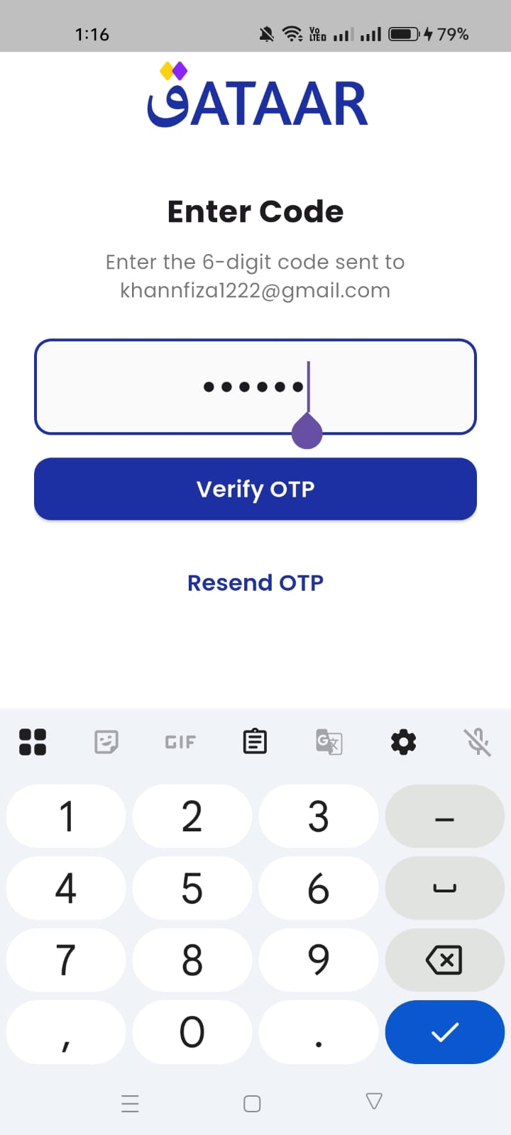
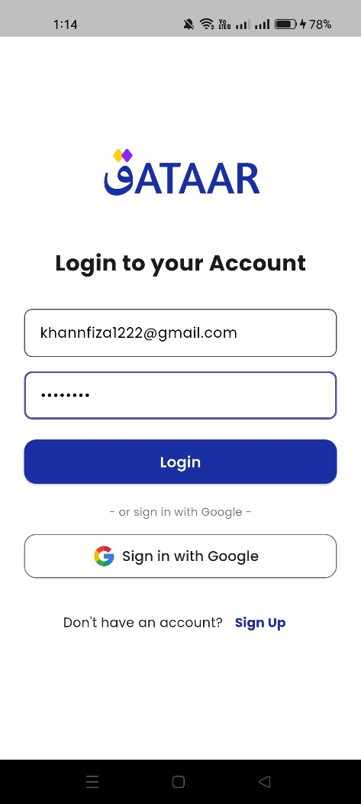
Figure 1: Splash Screen Figure 2: Login Screen Figure 3: OTP Verify Screen

Figure 4: Home Figure 5: Branch Browsing Figure 6: Services Screen
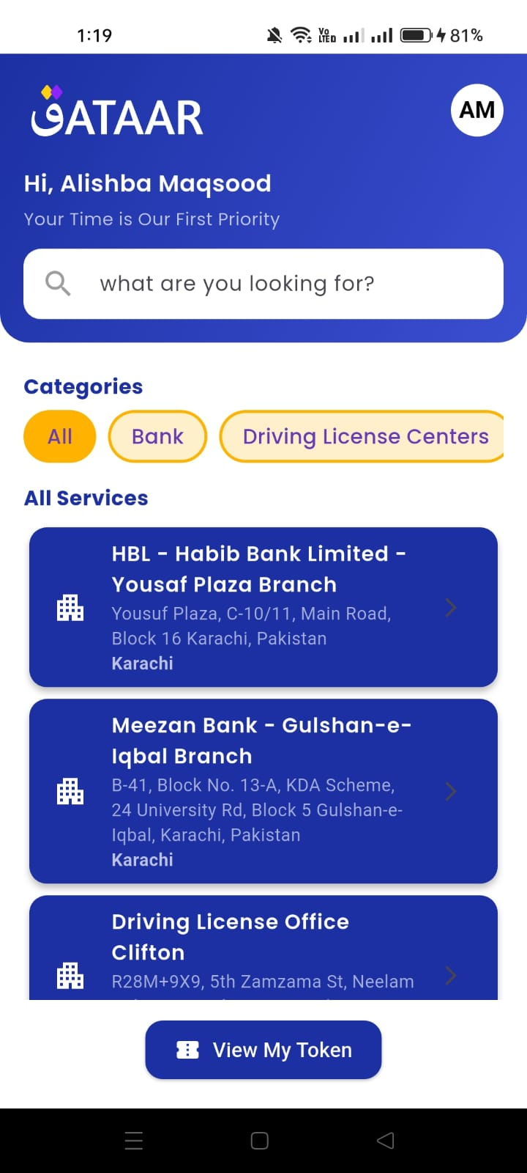
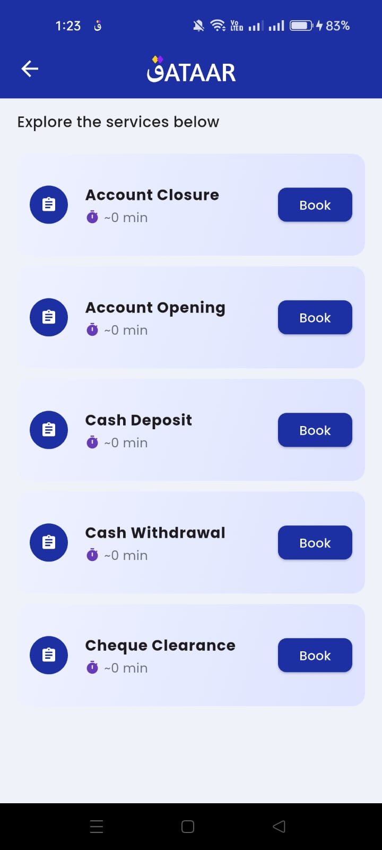
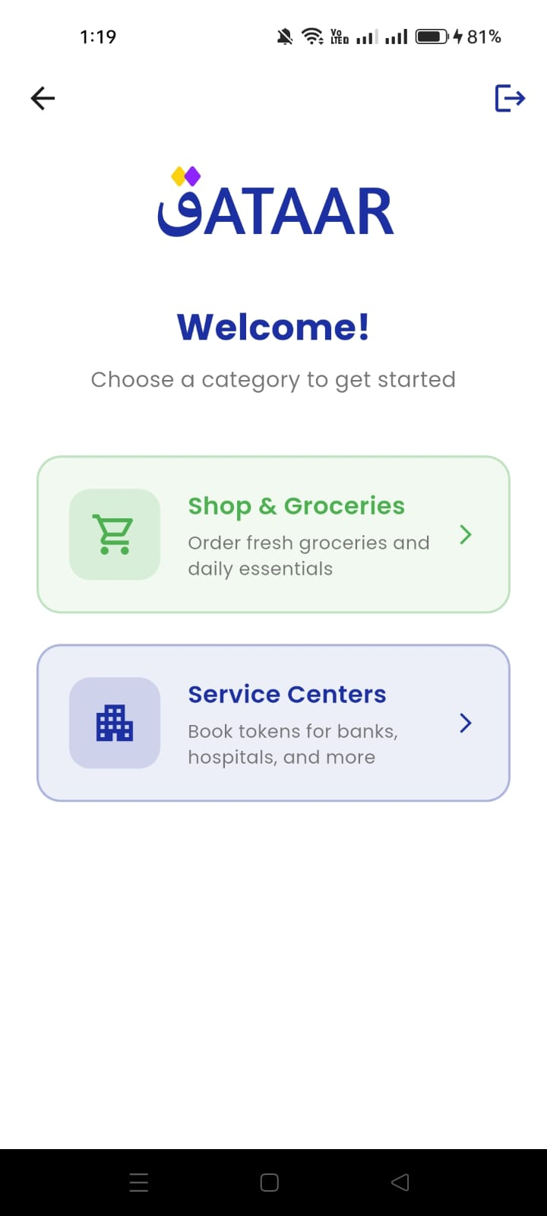
Figure 7: Services Token Screen Figure 8: Grocery Stores Screen Figure 9: Grocery Branches Screen
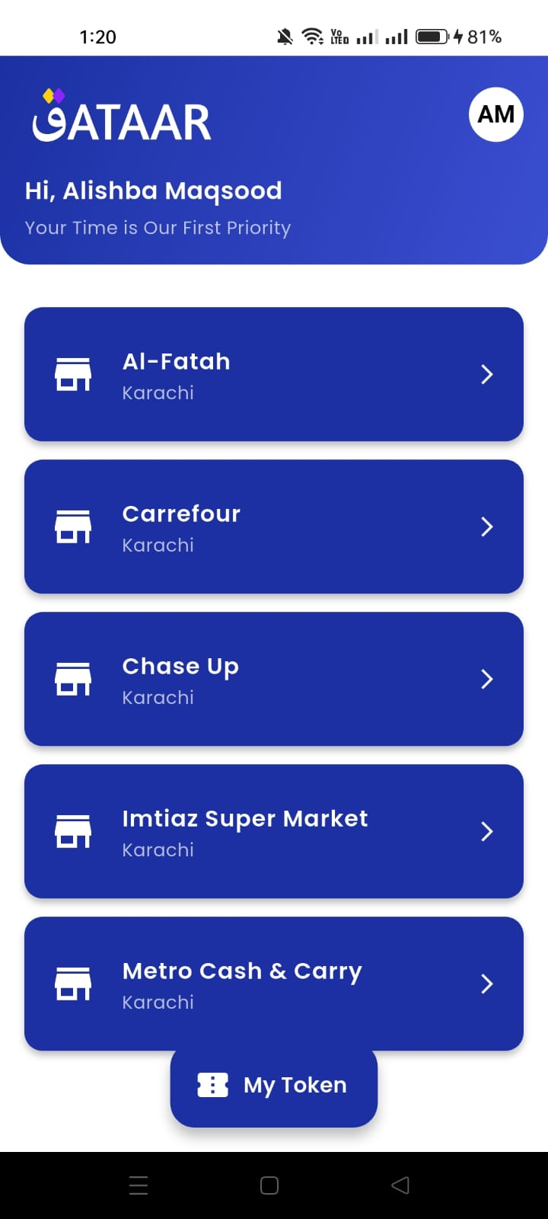
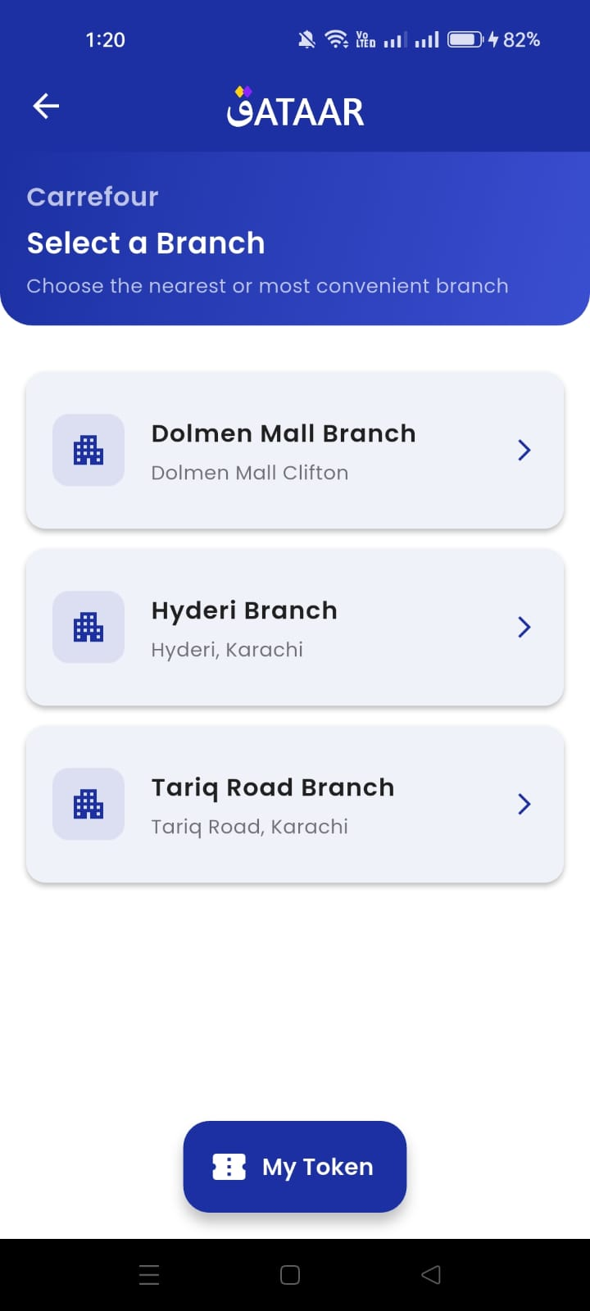
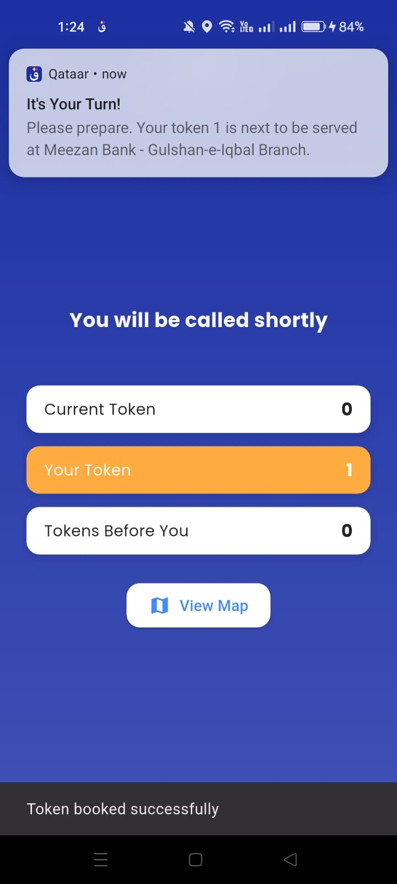
Figure 10: Grocery Input Screen Figure 11: Grocery Suggested Slots Figure 12: Grocery Token + QR
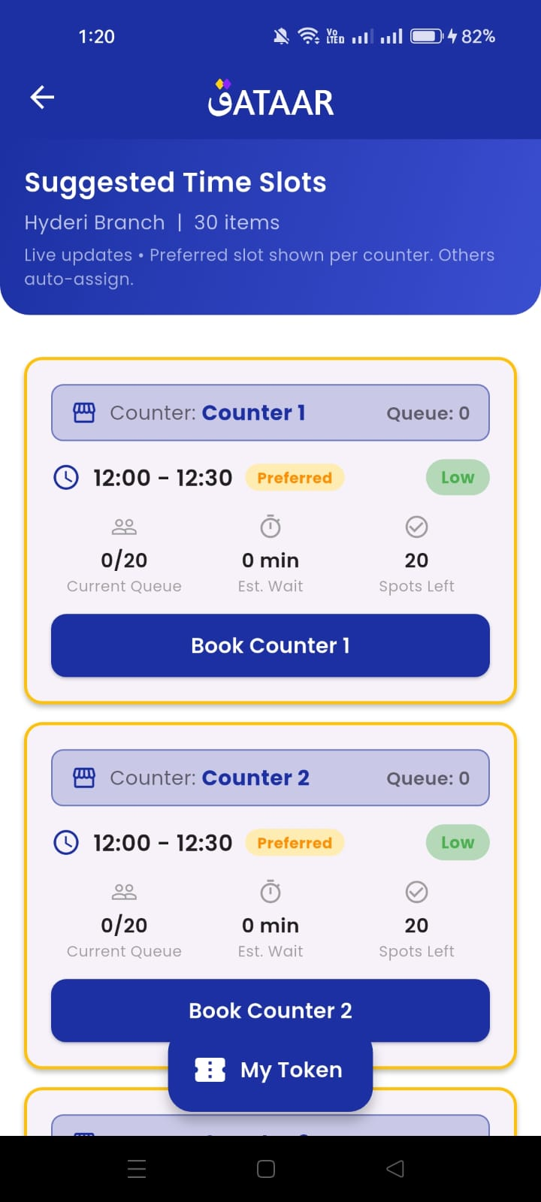
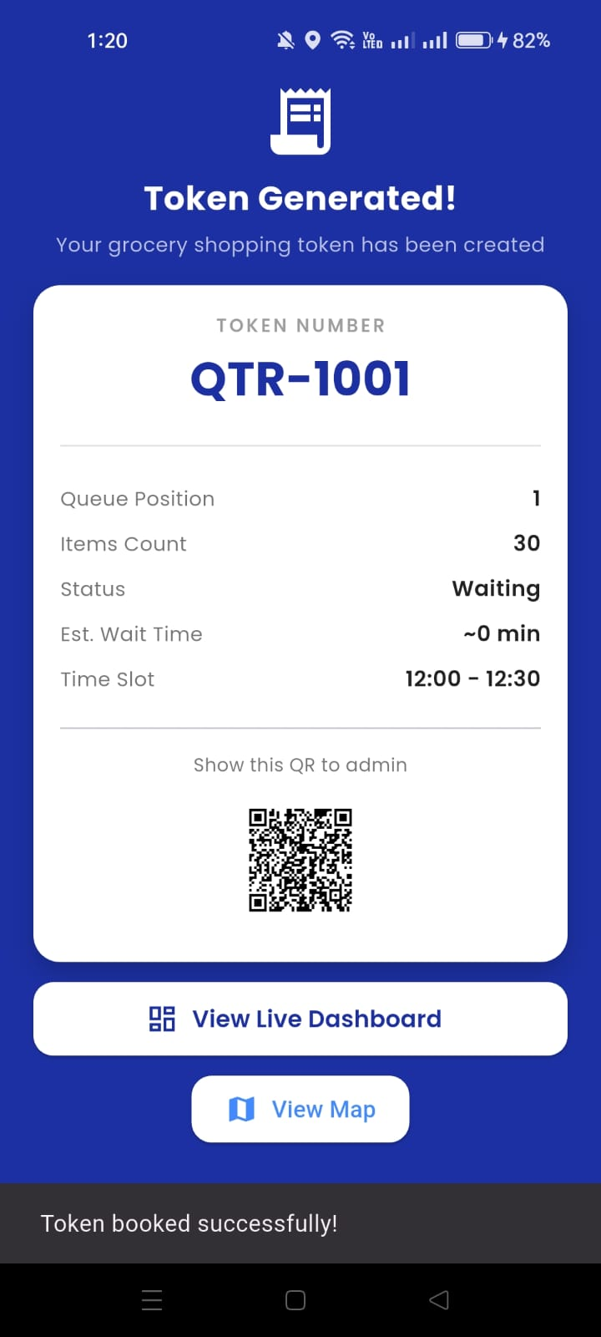
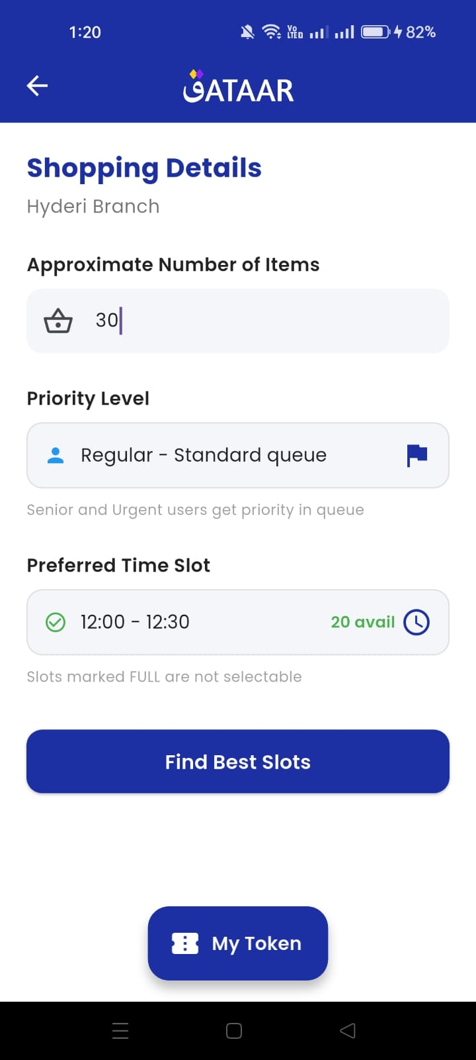
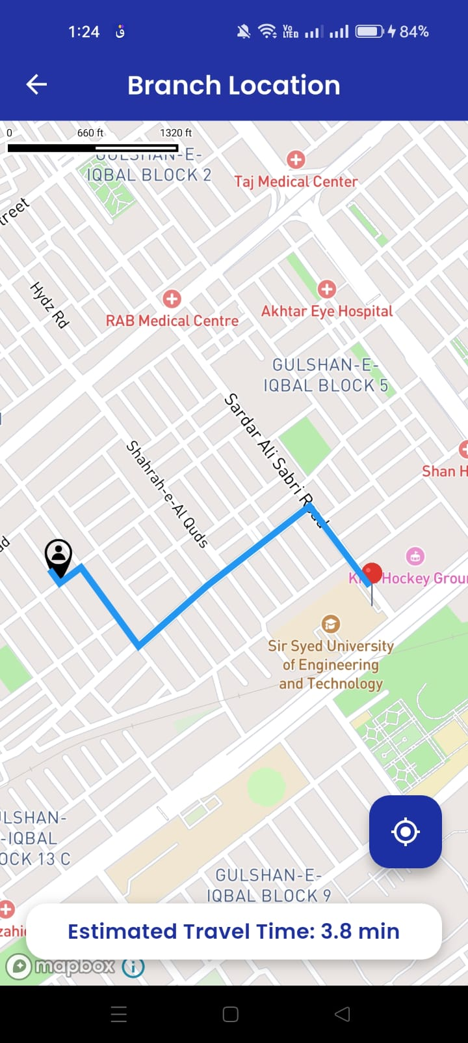
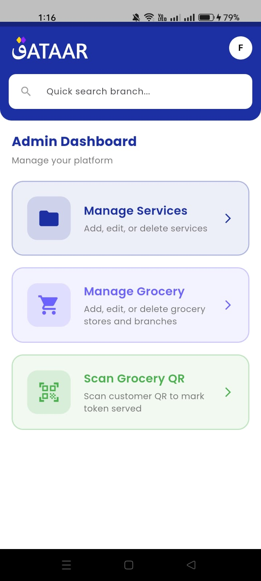
Figure 13: QR Scanner Screen Figure 14: Maps Screen Figure 15: Admin Dashboard
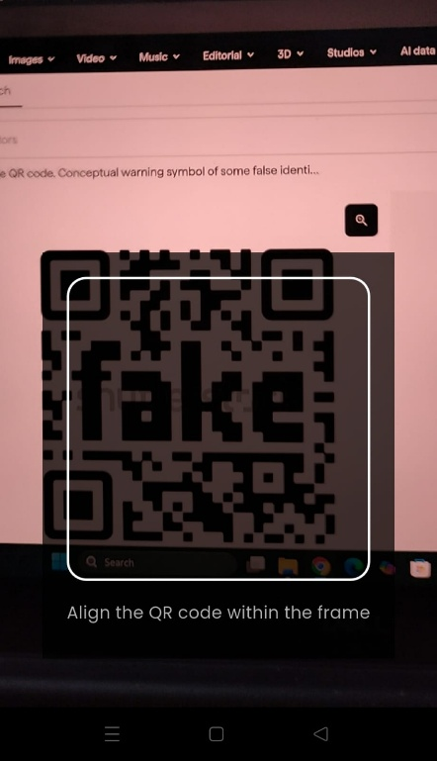

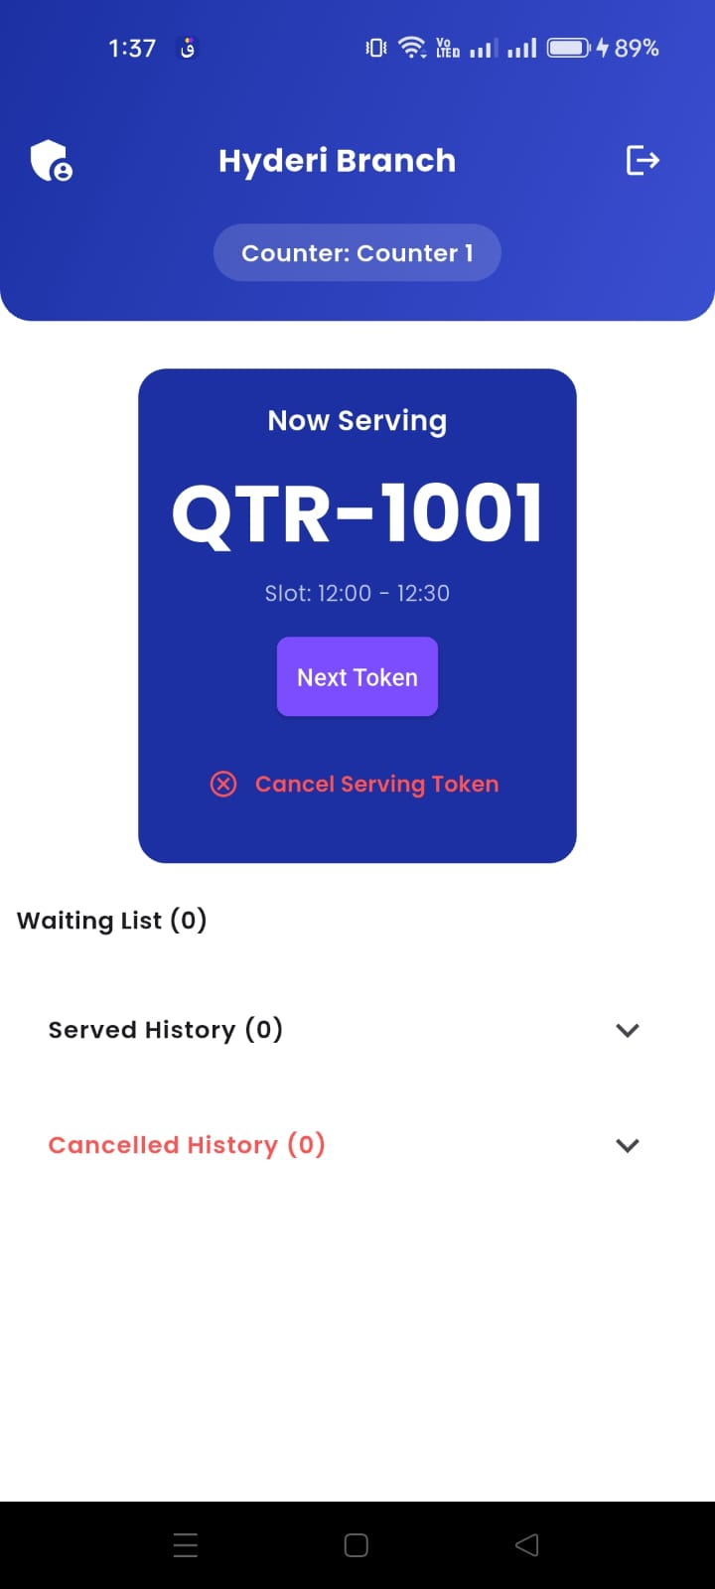
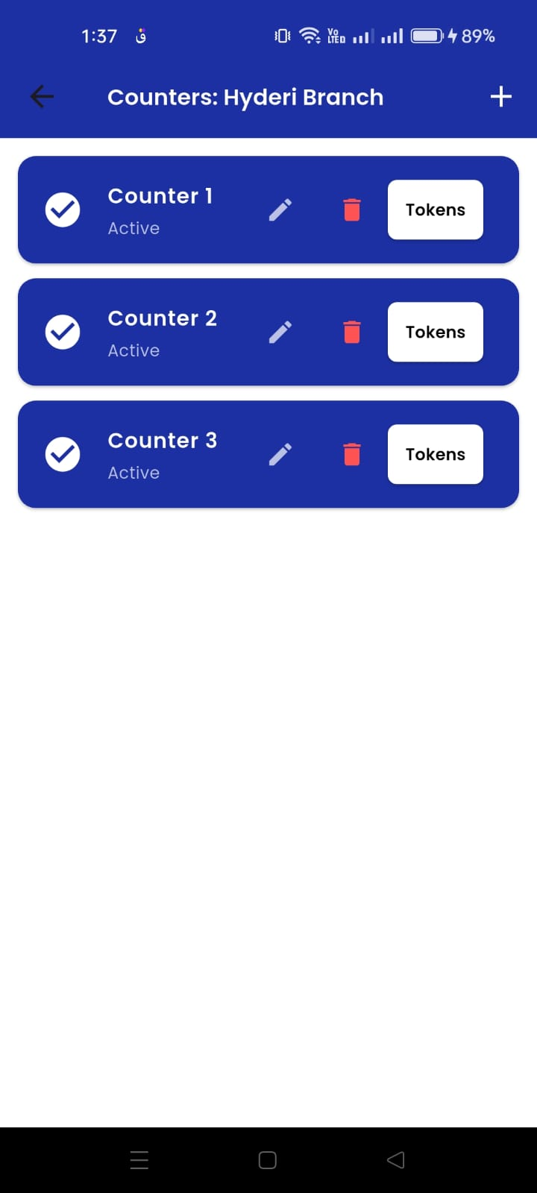
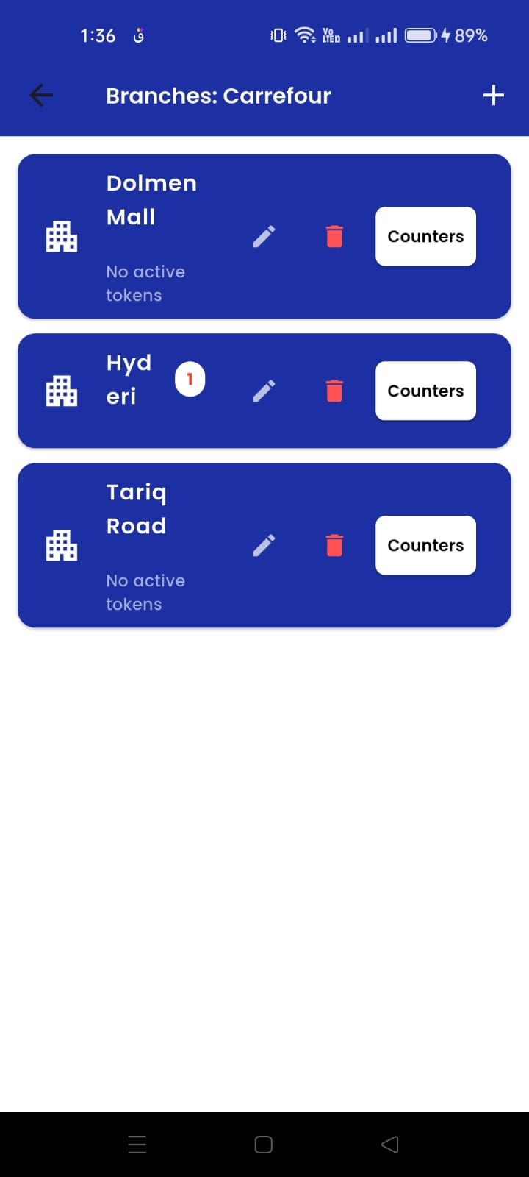
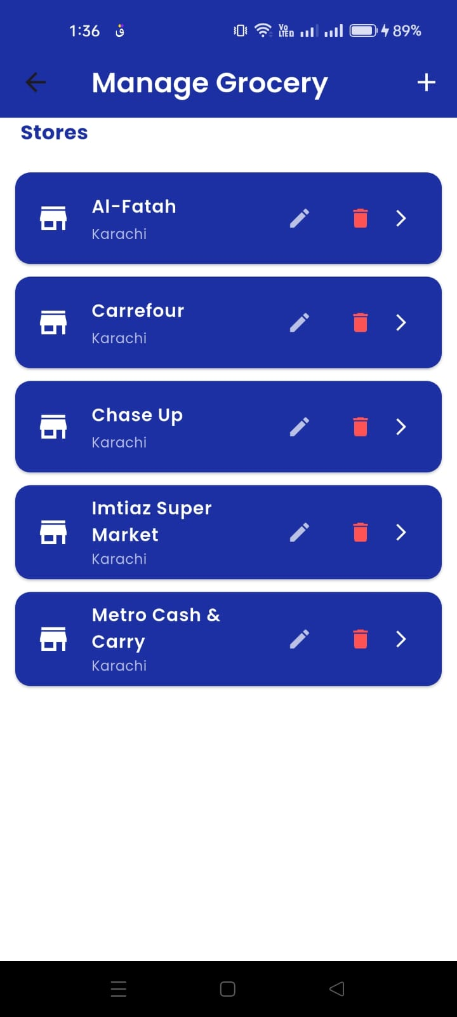
Figure 16: Admin Screens

5. Challenges and solutions

Challenge 1: Reliable notification delivery and UI display
- Problem: FCM messages may arrive when the app is in foreground/background, and the UI must still show user-friendly notifications.
- Solution:
  - Implemented both:
    - Foreground listener (FirebaseMessaging.onMessage.listen)
    - Background handler (annotated with @pragma('vm:entry-point'))
  - Used flutter_local_notifications to show consistent local notifications.

Challenge 2: Asynchronous Firestore document availability
- Problem: Some screens need to wait for token documents to exist right after booking.
- Solution:
  - Used StreamBuilder<DocumentSnapshot> to handle snapshot.hasData and snapshot.data!.exists conditions.
  - The UI shows a loading state (“Token is being prepared…”) until the doc exists.

Challenge 3: Queue timing correctness (“turn approaching” logic)
- Problem: Cron-based notifications must match server-side currentToken / queue state.
- Solution:
  - Services cron:
    - checks bookings against currentToken using tokenNumber math.
  - Grocery cron:
    - computes tokensAhead based on queuePosition and currentServingPosition.
  - Auto-skip cron ensures the queue doesn’t stall.

Challenge 4: Navigation issues after notification tap
- Problem: Notification tap routing needs a global navigator key; the current implementation mainly logs debug info.
- Solution:
  - Fallback approach: keep behavior functional (local notifications + logging).
  - Documented improvement need to support deep-link navigation.

Challenge 5: Performance issues with Firestore querying
- Problem: Naively fetching branches through multiple queries can lead to N+1 query overhead.
- Solution:
  - In HomeScreen, used Firestore collectionGroup('branches') to fetch all branch documents in a single query.

Challenge 6: Slot capacity enforcement for grocery tokens
- Problem: Prevent booking tokens beyond slot capacity.
- Solution:
  - Backend checks timeSlots/{slotId}:
    - compares bookedCount with capacity
  - Rejects booking when slot is full.

